Purpose: This webquest is designed to review principles of yeast bread preparation, and introduce you to yeast bread preparation methods. It will also introduce you to career paths associated with the baking unit.

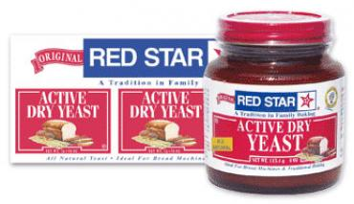
Yeast Breads

There are two companies that produce most of the yeast that we purchase in grocery stores in Maryland: Fleischmann’s and Red Star Yeast. We will be using the websites provided by both of these companies and other sites on the Internet to explore the history of yeast breads and yeast bread preparation in this webquest.

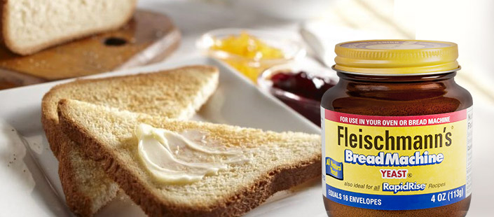
Instructions: Click on the links provided throughout this document to answer the questions that follow.

History of Yeast Bread Making

- Use the information provided by Red Star Yeast at http://redstaryeast.com/science-yeast/story-yeast/ to answer the following questions:
  - How long has yeast been used to make bread?

  - How were breads leavened in ancient (Bible) times?

  - When was yeast first identified as a living organism?

- Use the information provided on Fleischmann’s Website to answer the following questions about the history of their product:
  - Where was the first commercial yeast made in the United States?

  - Where did the Fleischmann brothers have a concession named The Vienna Bakery, a concession where they introduced their commercial yeast to the world?

  - What type of yeast did the Fleischmann brothers display at their concession in 1876?

  - Why does this website say that active dry yeast was invented?

  - How much faster does this company claim that rapid rise yeast is in baking than active dry yeast?

Yeast Bread Basics

- What is the main function or purpose of yeast in baked goods?

- What are three things that Louis Pasteur discovered about how yeast works?

- Name and describe the three roles that the yeast fungus, Saccharomyces cerevisiae, fulfills in baking, according to Red Star Yeast:

- We have reviewed the roles of many ingredients in the production of baked goods to this point in Food and Nutrition Technology. Please summarize the information provided on Fleischmann’s page regarding the roles that the following ingredients play:

  - Eggs:

  - Fat:

- Yeast breads are made from yeast that comes from various sources. Complete the chart provided below using the links provided on the name of the product:

Product Name/Type | Description | Special Considerations when Using this Yeast | Baked Product Examples  (You can search on the Internet for examples)
Cake Yeast

Active Dry Yeast

Instant Yeast (also known as Rapidrise Yeast)
Starter

- How can yeast be activated or proofed?

- At which temperature(s) will yeast be killed?

- How long will activated yeast dough last in the refrigerator if you need to stop in the middle of making it for some reason?

- Where should dough be placed to rise (or proof)?

- How long will packaged yeast last?

Yeast Bread Methods: Watch each of the following videos and compare the ways that bread is made in each of them in the chart provided below.

Method | Traditional White Bread | Bread Machine Bread | Italian Bread Made With a Sponge: Part 1, Part 2, and Part 3 | Factory-Produced Bread
Ingredients
How it is mixed, kneaded, and baked
Shape of Loaves
Time to prepare

Careers related to Baking: Chef Quest

Go to Food Network’s page where information is provided about the chefs who appear in their programming in the section Featured Chefs and Hosts. Explore the background of one or more chefs profiled on this page using the information provided here and on other places on the Internet (a Google or other search might be helpful here, obtaining the following information about them:

- Name:
- Education Received:
- Employment History:
- Shows on Food Network:
- Products/Licensing Agreements:
- Net worth (celebritynetworth.com might be helpful here):
- Provide a link to one yeast-bread recipe provided by this celebrity:
- How does this chef’s salary compare with the salary of a person who makes similar baked goods who isn’t a celebrity? (Google pastry chef or chef for possible salaries)

If you find yourself with time remaining in class, search for pretzel recipes on the Internet and provide links to your favorites below:

Note: Once you have downloaded this file, save it in your documents with your name as YourNamePeriod#BWQ For example: DrBrownePeriod1BWQ. You will be e-mailing your work to Dr. Browne at Lorna_Browne@hcpss.org when you are finished.

